WORKSHOPS

The aims and objectives for workshops are to stimulate an appreciation of the art of quilting; to encourage fellowship; and to share, learn, teach and promote old and new ideas, techniques and designs. Our workshops are geared towards all levels of quilters, from beginner to advanced. The goal is to make the workshops as affordable as we can so that all members of the guild can participate if they wish.
If a workshop is not full at any time we do open up the program for outside guests. Upcoming workshops are listed on our website calendar. An example of one of our workshops is given below.
Celtic Letter Workshop – September 23rd 2016
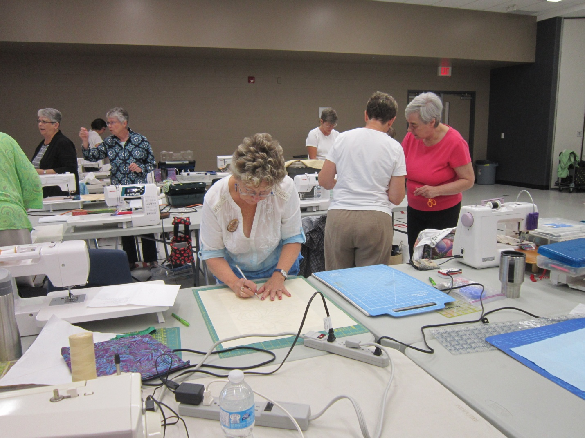
Convenors were Midge Trauzzi and Pat Burke.
A large group of quilters attended this workshop held at the Brighton Community Centre. The workshop was taught by Louise Manning who also taught the Gordian Knot workshop in March 2016. Louise hails from Fenlon Falls. Attendees were asked which letter they wished to quilt and patterns were provided by Louise. We had great fun tracing our letters on to fusible webbing which was then transferred on to our focus fabric. The focus fabric was bonded to the background fabric. The large windows at the Community Centre were used by many of us as light boxes. The rest of the design was then traced on to the background fabric. We learned many new techniques including using wool yarn for detailing the piece. Louise helped us all with her sage advice during her many walk- a-bouts around the room.
The workshops are a great way to meet new friends and to learn new (to you) quilting techniques. We encourage all our members to join us.

